**User Manual**

**On**

**Forum Management System**

**Project Manager:**

**Dr. Kazi Masudul Alam**

**Associate Professor**

**Computer Science & Engineering Discipline**

**Khulna University, Bangladesh**

**Developed by:**

**Deep Dutta(140205)**

**Kushal Ghosh(140223)**

**Home Page:**

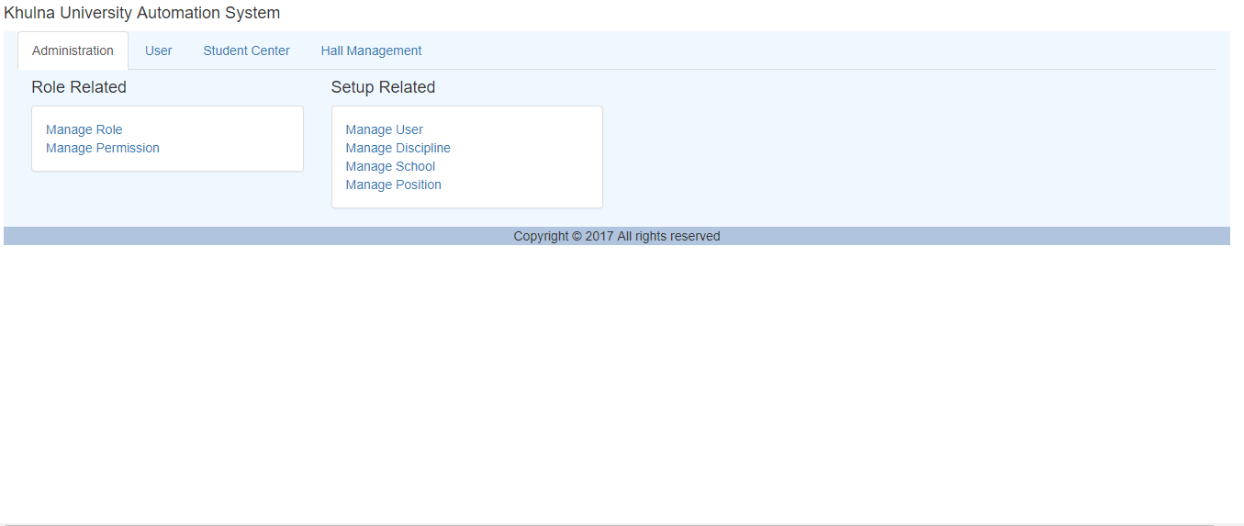

*Fig: Home Page*

There are four section.

1.Administration.

2.User.

3.Student Center.

4.Hall Management.

We work in the Student Center.

Details are given in bellow:

1. **Discussion Topic:**

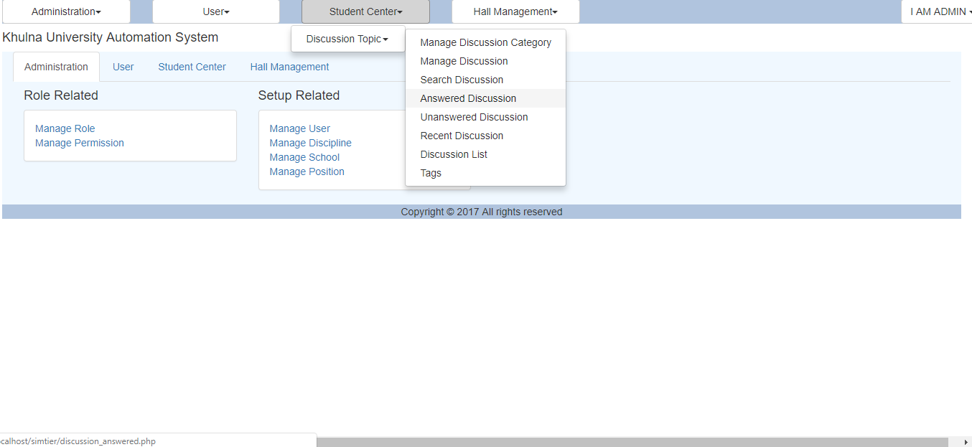

*Fig: Discussion Topic*

In the Discussion topic there are eight section.

1.Manage Discussion Category

2.Manage Discussion

3.Search Discussion.

4.Answered Discussion

5.Unanswered Discussion

6.Recent Discussion

7.Discussion List

8.Tags

**Manage Discussion:** In this section the question will be given.

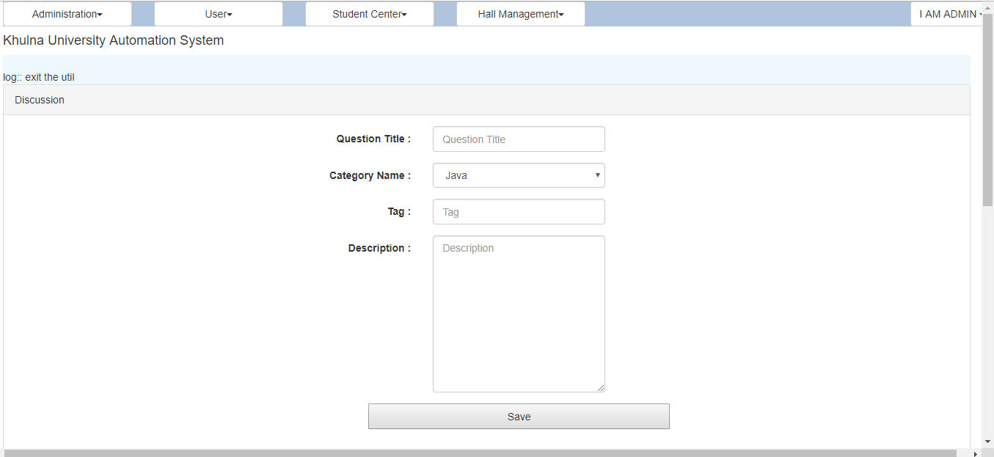

*Fig: Manage Discussion Page*

Question will be given with title, category name & tag. The description of the question will be given in description box.

**Manage Discussion:** This page also manage discussion page. In this page there are three new attributes. They are Views, Answers & Votes. And also two button, they are edit & delete. If any one click any question then the views value will increase. Edit & delete button use for edit question and delete question.

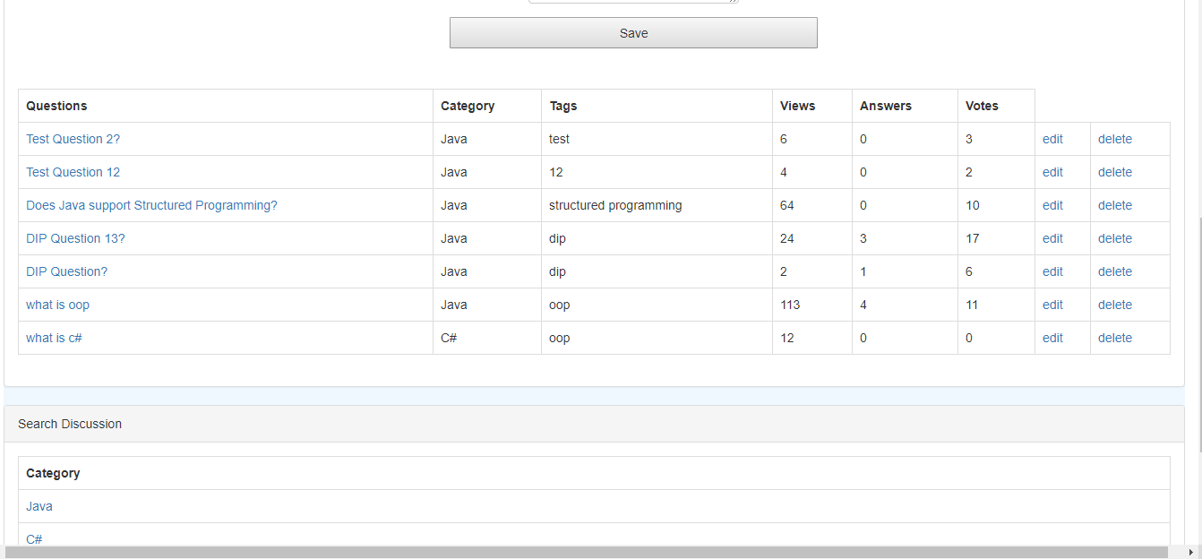

*Fig: Manage Discussion Page*

**Question Vote:** This page show the question votting.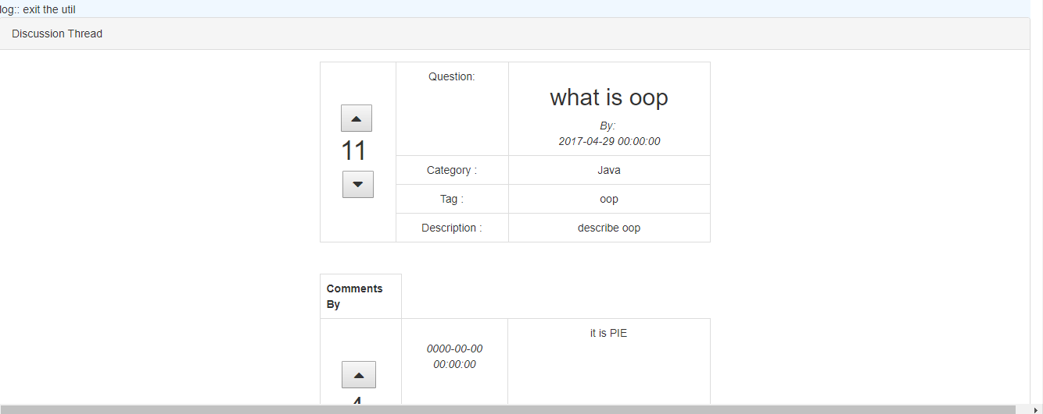

*Fig: Question vote*

**Answer with vote:** In this page the question answer is given with vote.

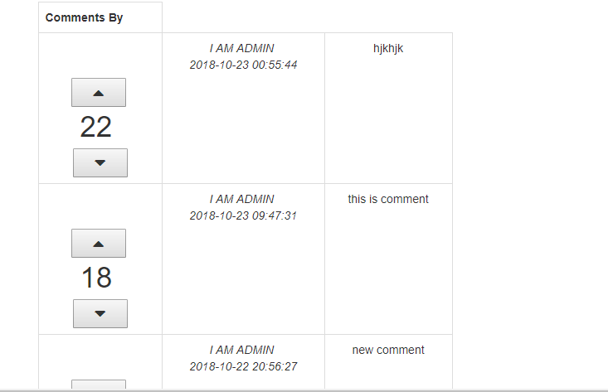

*Fig: Answer with vote*

**Edit :** In this page questions are edited.

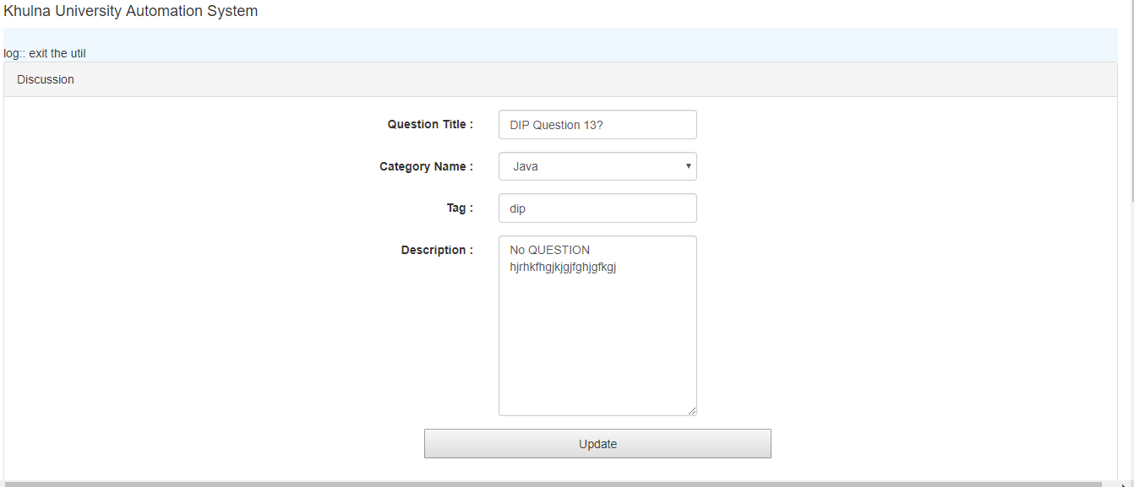

*Fig: Edit Page*

**Tag Page:** In this page how many question is asked for same topic are given.

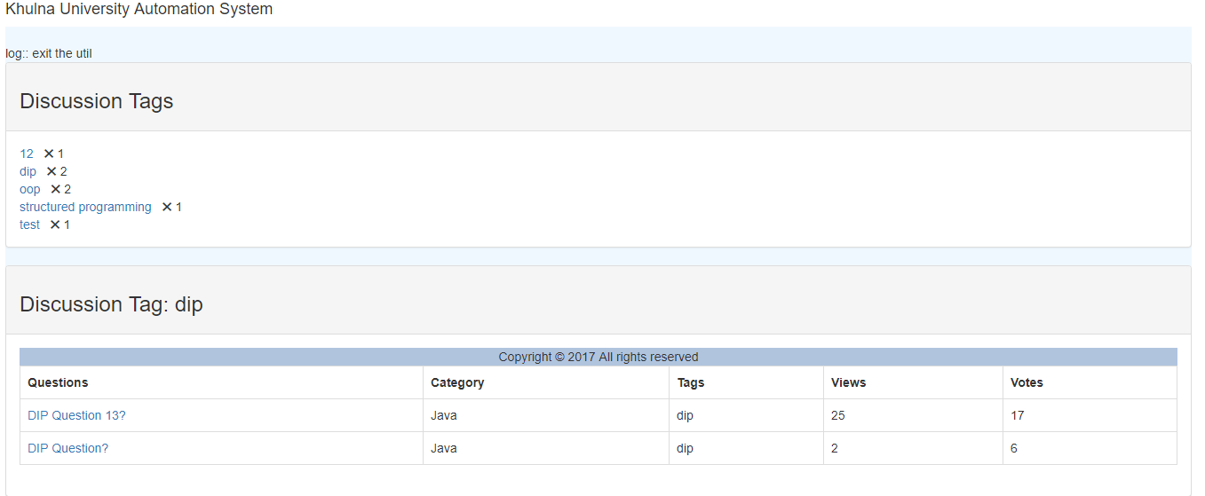

*Fig: Tag Page*

Thank You